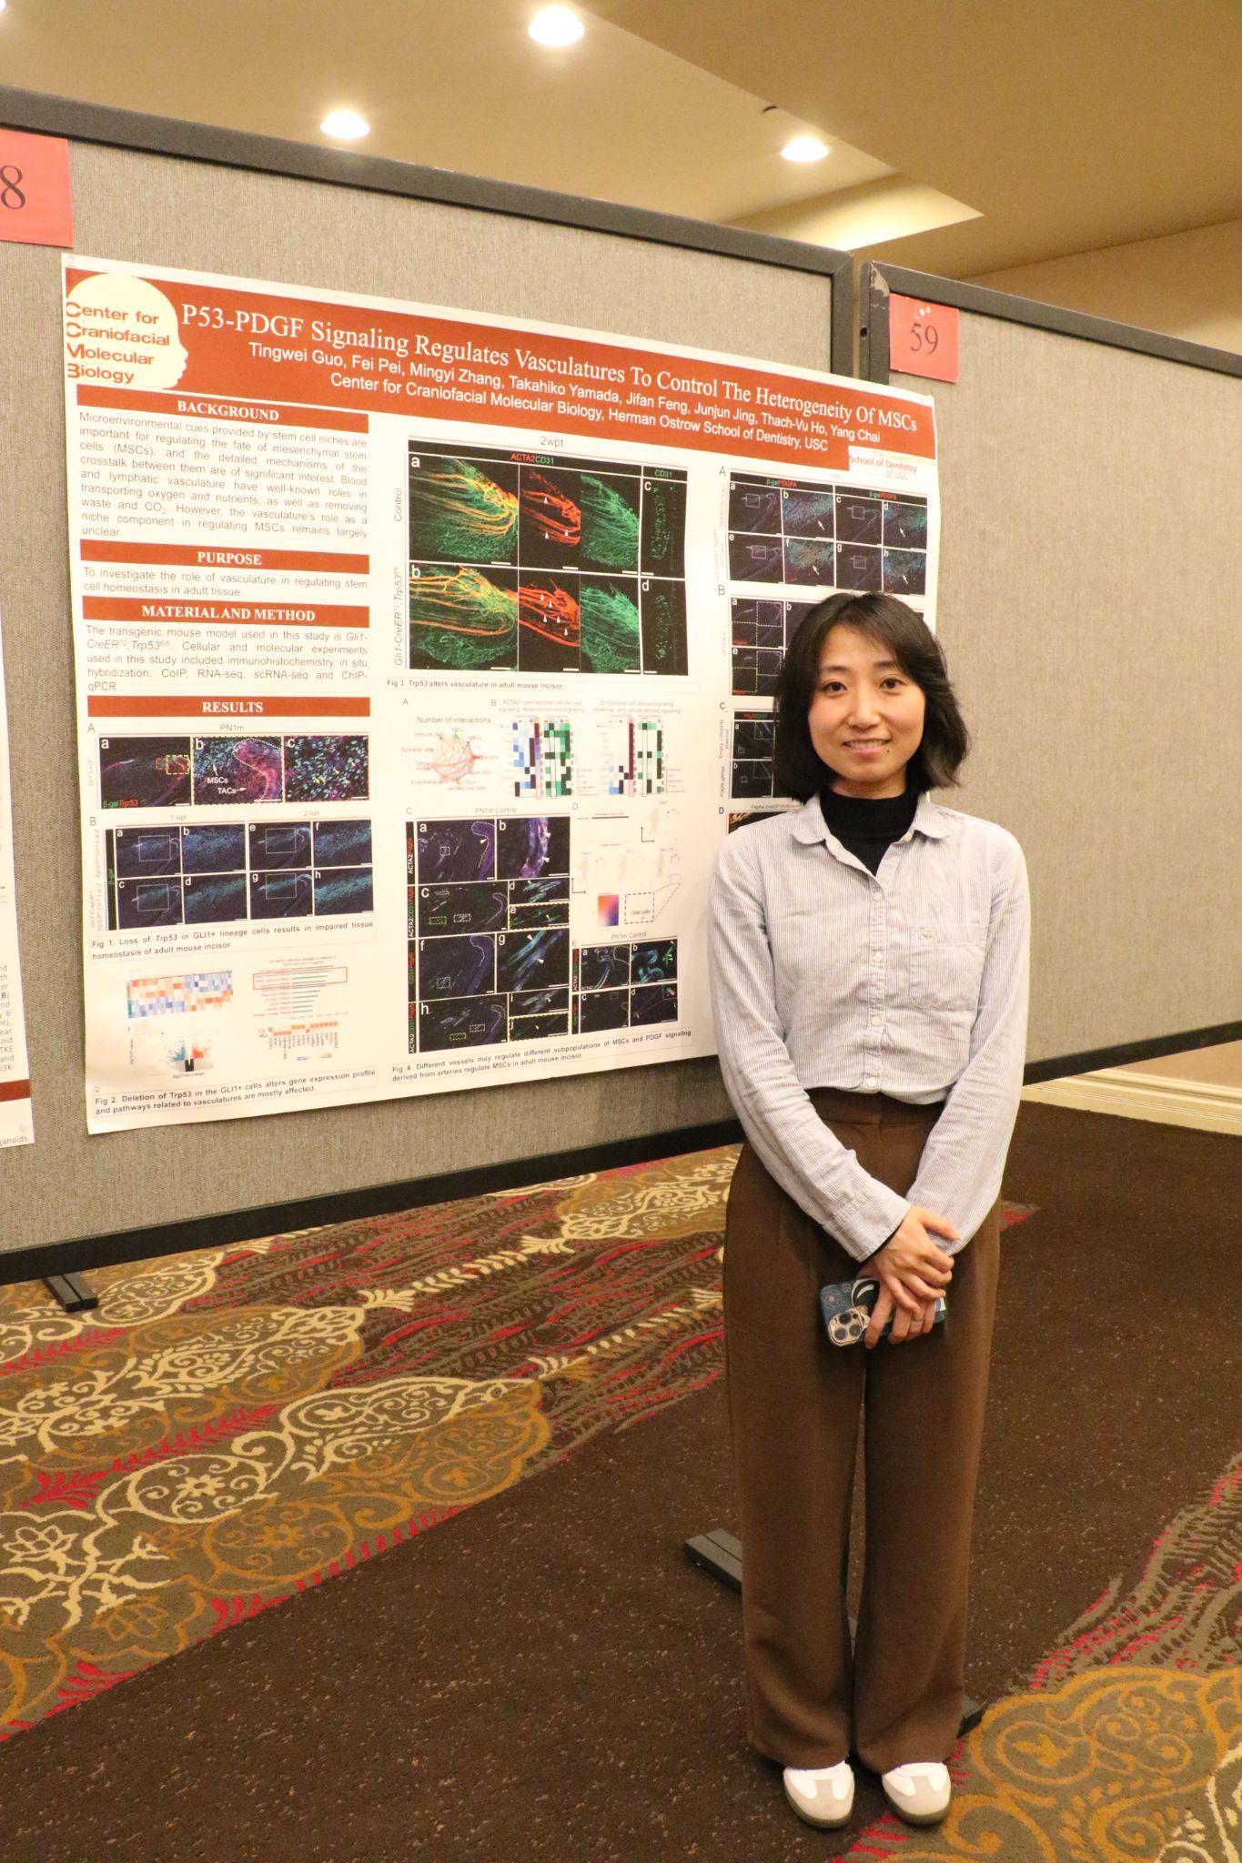
P53-PDGF Signaling Regulates Vasculatures To Control The Heterogeneity Of MSCs
Tingwei Guo, Fei Pei, Mingyi Zhang, Takahiko Yamada, Jifan Feng, Junjun Jing, Thach-Vu Ho, and Yang Chai*
Center for Craniofacial Molecular Biology, Ostrow School of Dentistry University of Southern California, Los Angeles, CA 90033, USA
Background: Microenvironmental cues provided by stem cell niches are important for regulating the fate of mesenchymal stem cells (MSCs), and the detailed mechanisms of the crosstalk between them are of significant interest. Blood and lymphatic vasculature have well-known roles in transporting oxygen and nutrients, as well as removing waste and CO₂. However, the vasculature’s role as a niche component in regulating MSCs remains largely unclear. Purpose: To investigate the role of vasculature in regulating stem cell homeostasis in adult tissue. Methods: The transgenic mouse model used in this study is Gli1-CreER^{T2};Trp53^{fl/fl}. Cellular and molecular experiments used in this study included immunohistochemistry, in situ hybridization, CoIP, RNA-seq, scRNA-seq and ChIP-qPCR. Results: Our study shows that the loss of Trp53 in GLI1+ progeny reduces THBS2, which leads to alterations in the vascular architecture including an increase of arteries and a decrease of other vessel types. These changes further result in an increased deposition of artery-derived PDGFA and PDGFB at the proximal MSC region, where they interact with PDGFRA and PDGFRB. Significantly, PDGFRA+ and PDGFRB+ cells differentially contribute to defined cell lineages in the adult mouse incisor. Conclusion: This study shows how different vessels can provide unique microenvironmental cues to regulate subpopulations of MSCs and maintain their heterogeneity, and establishes mechanistic insight into the crosstalk between vasculature and mesenchymal stem cells. Funding support: We appreciate the funding support from the National Institute of Dental and Craniofacial Research, National Institutes of Health (R01 DE012711, R01 DE025221, and U01 DE028729 to Yang Chai).

