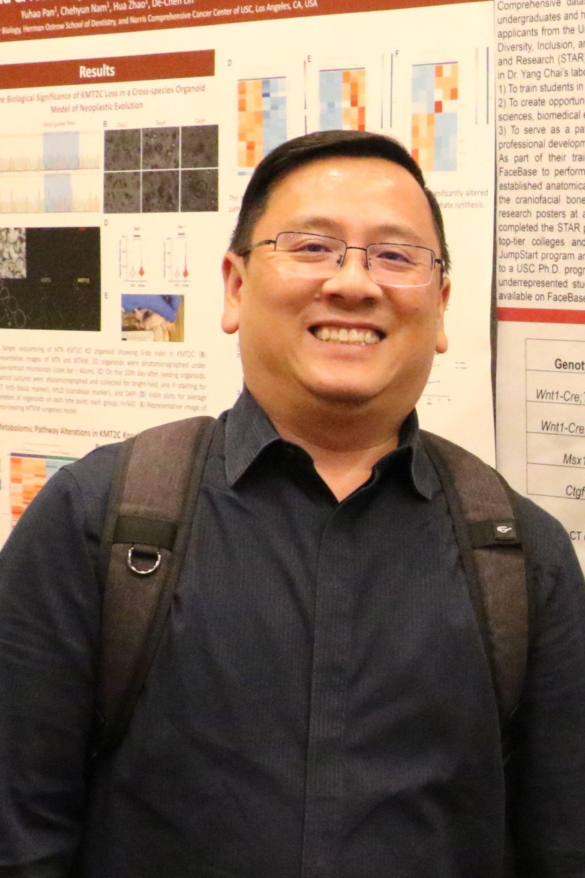
Training Underrepresented Students on Craniofacial Research at USC
Thach-Vu Ho, Janet Sanchez, Jesse Anderson-Ramirez, Ishmael Howard, Yang Chai*
Center for Craniofacial Molecular Biology, Ostrow School of Dentistry University of Southern California, Los Angeles, CA 90033, USA
Background: Underrepresented students from local communities are provided research opportunities in STEM, social sciences, and humanities at the University of Southern California (USC). Purpose: Each year, several students from the USC Graduate Initiative for Diversity, Inclusion, and Access (DIA) JumpStart and USC’s Science, Technology, and Research (STAR) programs have the opportunity to conduct craniofacial research at the Center for Craniofacial Molecular Biology (CCMB) under the mentorship of the faculty. Methods: As part of the training, students learned hands-on research skills, such as harvesting tissue samples from animals and processing samples for various biochemical assays. Using available datasets and tools on FaceBase, students performed morphometric analyses of craniofacial bones. They labeled anatomical landmarks and quantified the size and shape of the craniofacial bones. Results: Students learned to organize their findings into a presentation and presented their research posters at research symposia. Conclusion: This research opportunity trains and provides underrepresented students in the scientific research pipeline for the STEM workforce.

Funding support: NIDCR, NIH U01 DE028729 to Yang Chai

